Well, it’s been a year of change and exiting happenings!
We spent the autumn term with Abbie still leading us, the culmination of our work was a fabulous Christmas concert at the Arts Centre. That evening, we sadly said goodbye to Abbie and wished her well for the future.
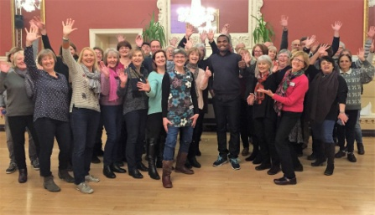
January saw the committee focus hard on searching for a new leader. The choir finally chose Emmanuel Omuederiaye and he officially started with us in February 2017. We are delighted that our weekly sessions with Emmanuel have proved to be both a time of learning and fun as we get to know each other. With his amazing gift for writing music, Emmanuel has brought great depths to some of our old numbers by adding in stunning new harmonies . In addition, he is gradually teaching us some new songs, both his own compositions and versions of contemporary, gospel and traditional world music songs. Most recently we have been learning a song in Emmanuel’s own Nigerian language and we felt very proud when he seemed pleased with our pronunciation and the sound we made ! Always room for improvement though !
With plenty of change going on, we decided against a formal concert this summer, instead we worked towards an open evening to showcase some of our work. Families and friends were invited to a relaxed evening of entertainment by the choir, while enjoying some food and drink café style. Emmanuel also taught everybody a new song and our visitors enjoyed participating. Our final evening of the year was done as a workshop, inviting any potential new members to come and give us a try. Several new faces attended, and we hope to have some recruits this autumn.
With the summer holidays now behind us, we are looking forward to another year with Woven Chords, moving from strength to strength under our new leader. Look out for details of our Christmas concert this December. And if you are thinking of joining a choir this year, do come along and give us try on a Thursday evening. Just make yourself known to a committee member and they will make sure you feel welcome.
Best wishes
The Committee
Woven Chords

